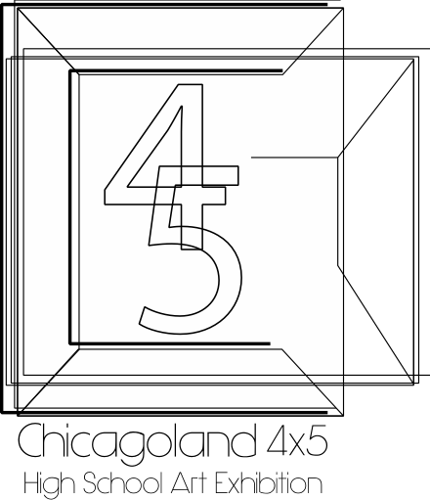
The Chicagoland 4x5 Art Exhibition
Hosted by Oswego High School

CC

School Code #

Please Type ALL information.
Name of School________________________
Phone Number_________________________
Contact E-mail_________________________
Total Number of Entries_________________
Total Number of Faculty Entries__________

Entry # | Name of Artist | Category | IN | OUT
CC-01 | Adams, Ansel | Photography
CC-02 | Adams, Ansel | Photography
CC-03 | Escher, Maurits | Drawing
CC-04 | Monet, Claude | Painting
CC-05 | Picasso, Pablo | Sculpture
CC-06 | van Rijn, Rembrandt | Painting
CC-07 | van Rijn, Rembrandt | Drawing
CC-31 | VanGough, Vincent | Teacher

